Scenario: check windowhandles
Step: Launch "framesPage" WebPage - PASS
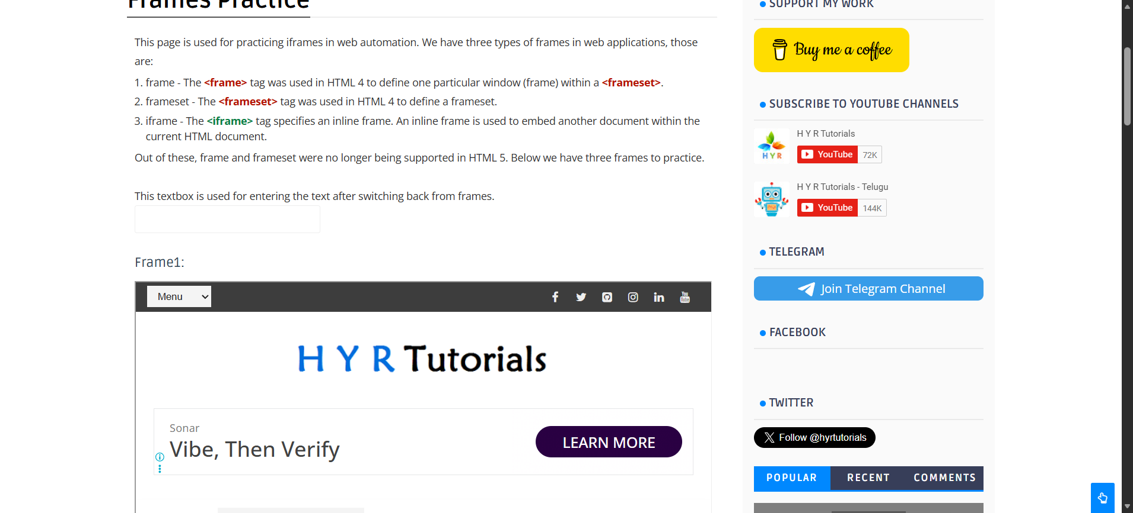
Step: And the user enters "subbu" into the "inputbox" textbox at the "WHPage" page - PASS
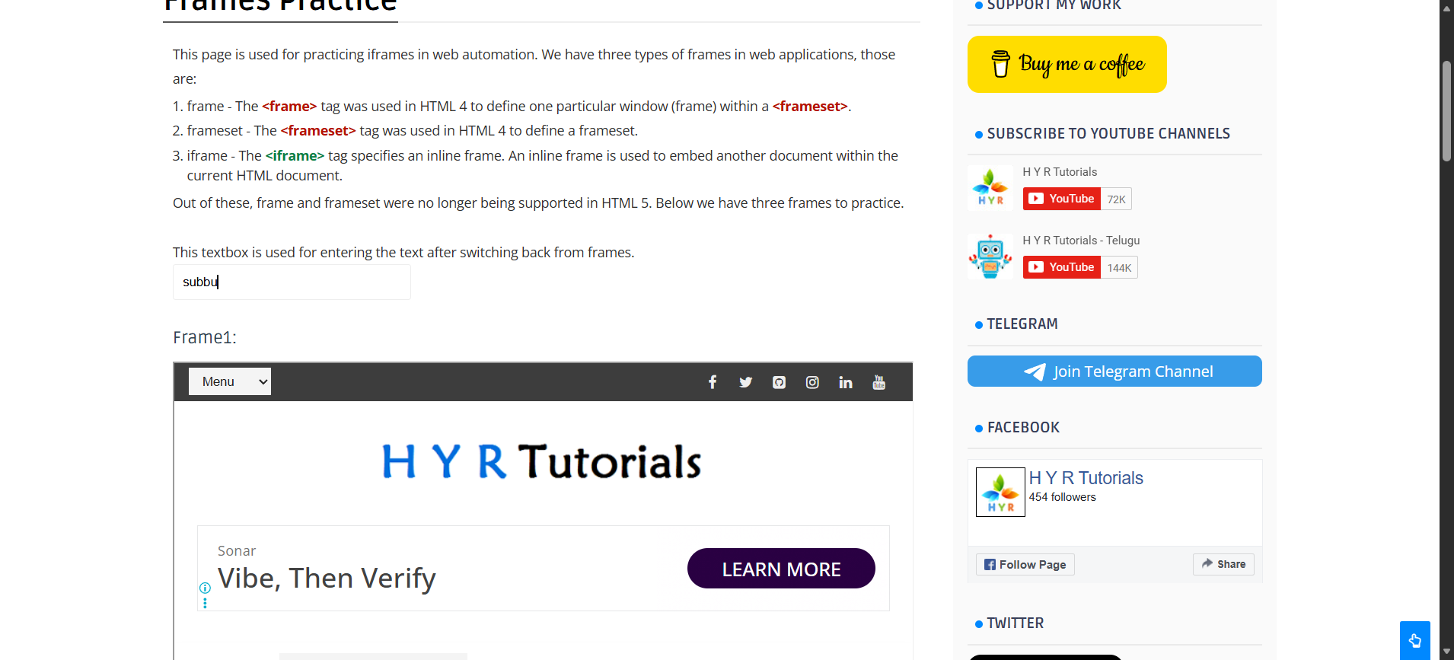
Step: And the user switches to frame "frame1" in "WHPage" page - PASS
Step: And the user switches to DefaultFrame - PASS
Step: And the user enters "ramya" into the "inputbox" textbox at the "WHPage" page - PASS
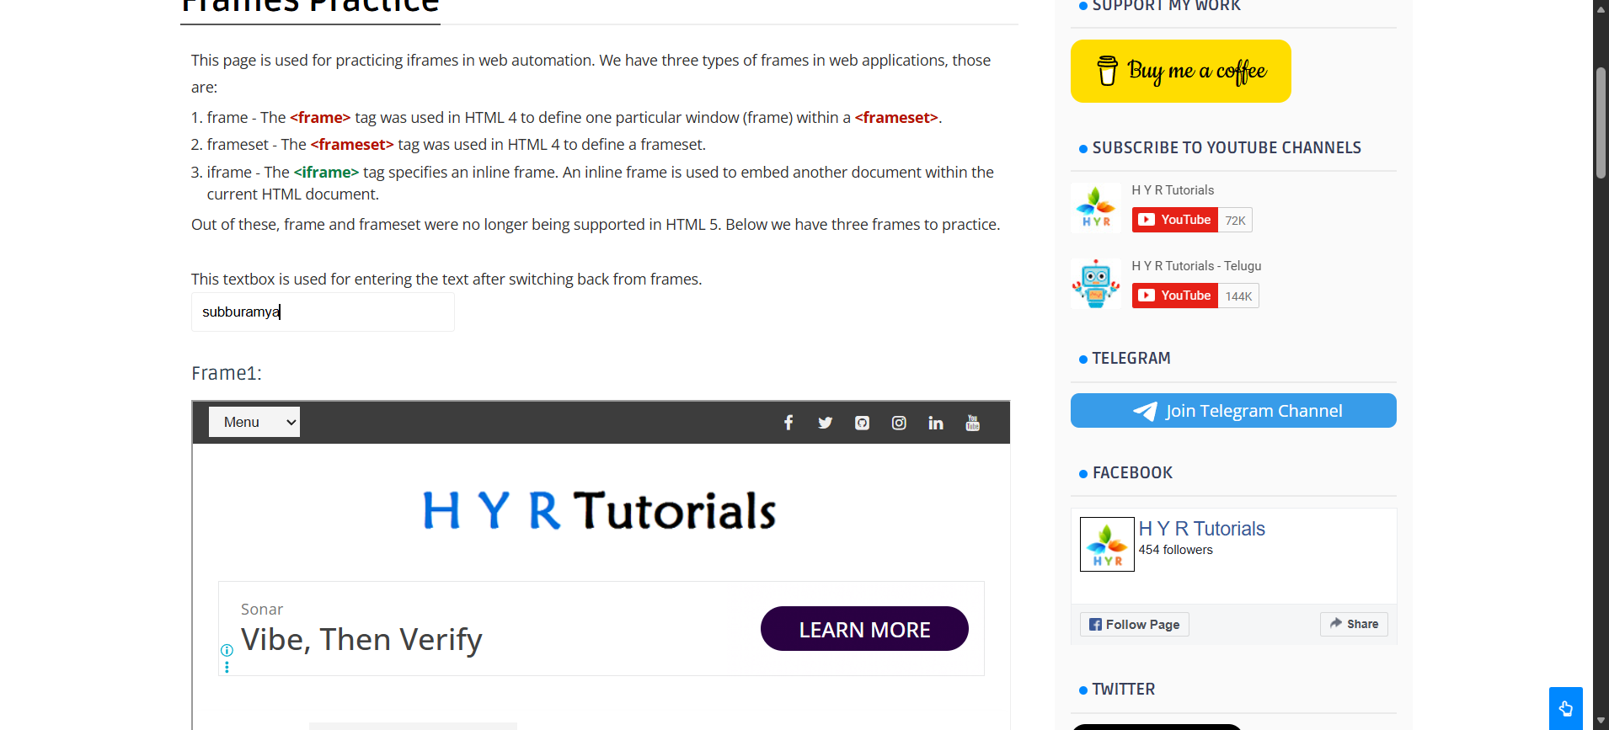
Step: And the user waits for "5" seconds - PASS
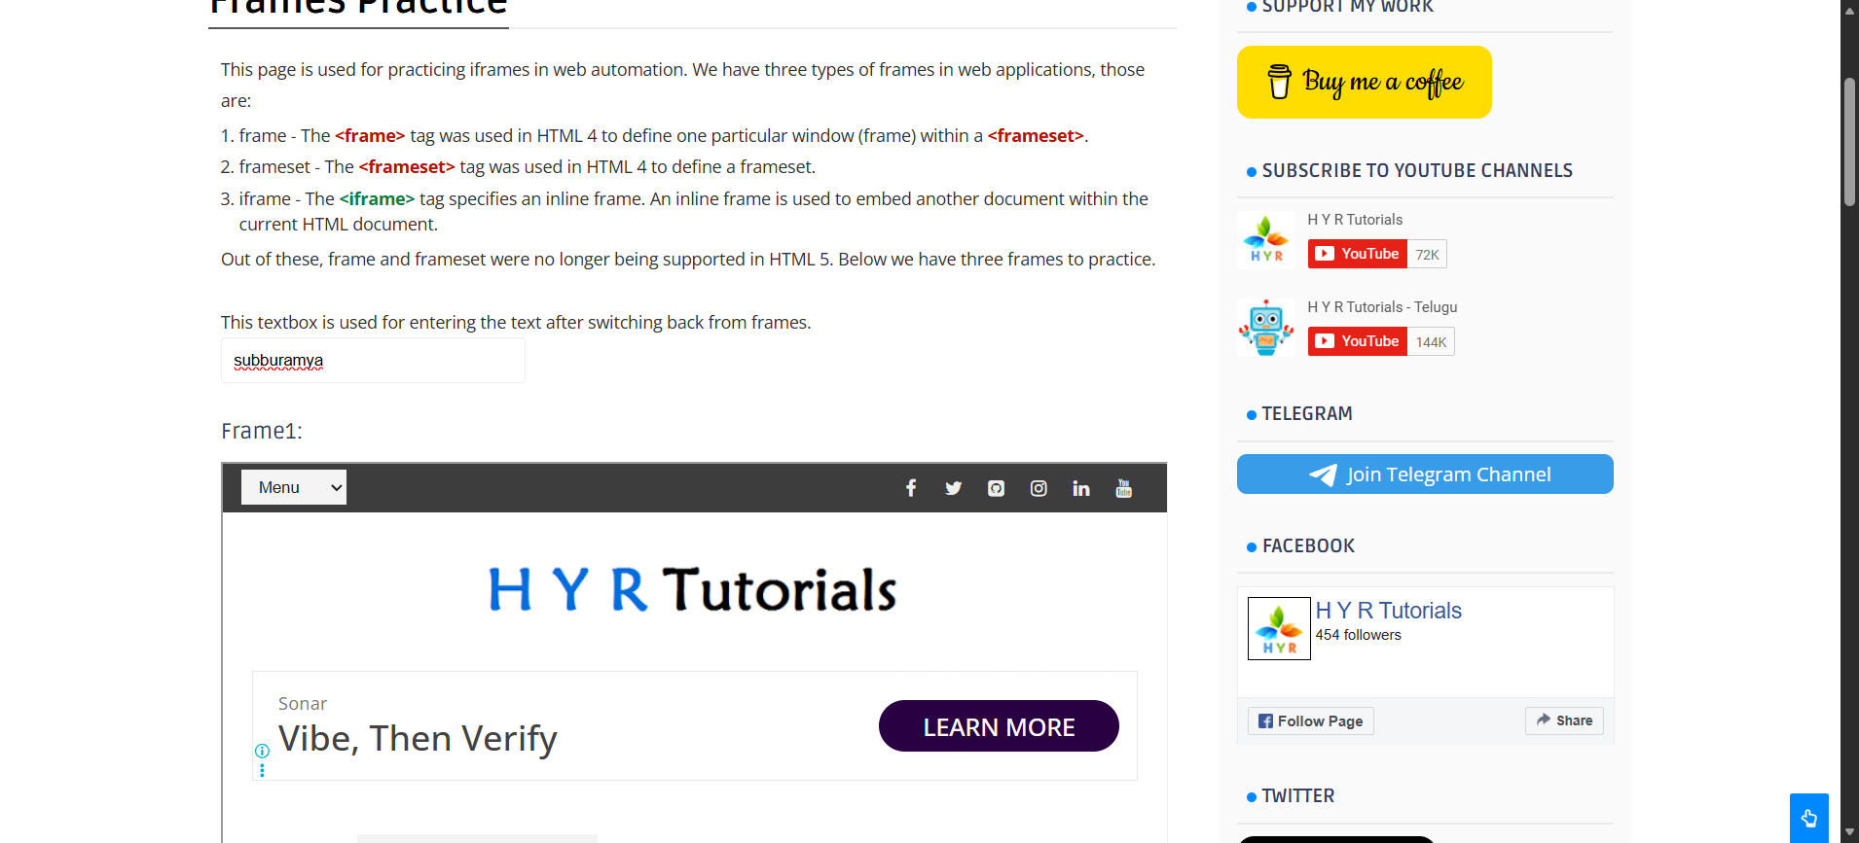
Execution Summary:
Total Steps: 6
Passed: 6
Failed: 0

